<https://www.npmjs.com/package/cxlt-vue2-toastr>

Step 0 : npm install cxlt-vue2-toastr --save

Now in app.js,

import CxltToastr from "cxlt-vue2-toastr";

import "cxlt-vue2-toastr/dist/css/cxlt-vue2-toastr.css";

var toastrConfigs = {

    position: "top right",

    showDuration: 2000

};

Vue.use(CxltToastr, toastrConfigs);

\*\*\*modify korear jonno like timing,duration, in (app.js),

var toastrConfigs = {

    position: "top right",

    showDuration: 1000,

    timeOut: 2000

};

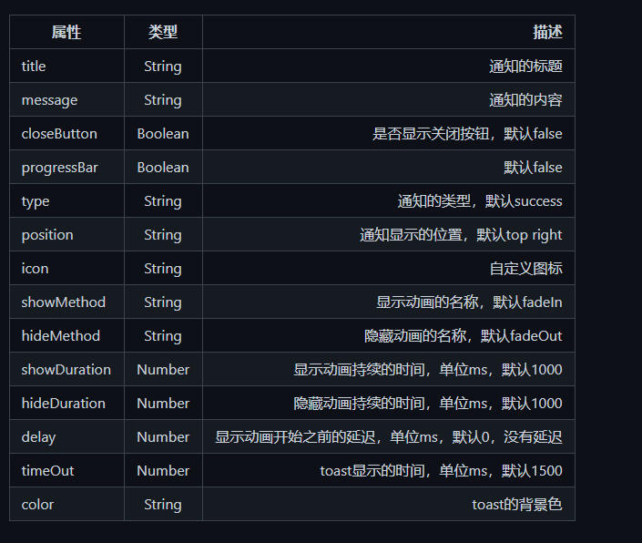

Ekhn code er moddhe etake jevabe add korte hoy, Example code from create.vue,

 this.categoryForm.post("/api/category").then(({ data }) => {

                this.categoryForm.name = "";

                this.$toast.success({

                    //toaster code

                    title: "Success",

                    message: "Category created successfully"

                });

            });